## Assignment 1 ZhuoranYu

Q2 Write a program that prints a multiplication table for numbers up to 12

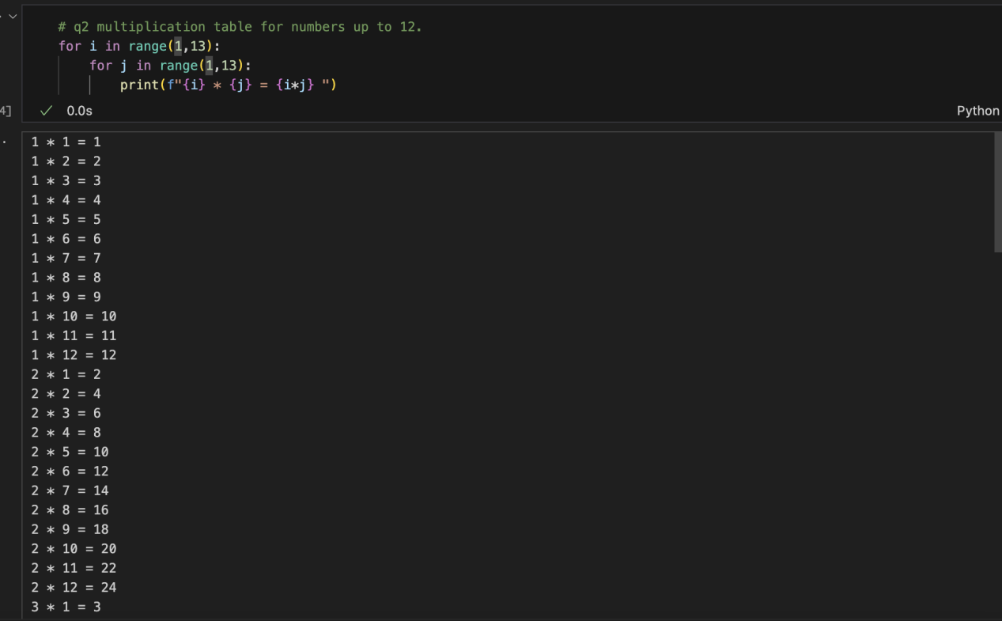

Q3 Write a program that asks a user to input a string and then determine if it’s a palindrome. If it is, print out “The string [is | is not] a palindrome. If the user types q, the program exits.

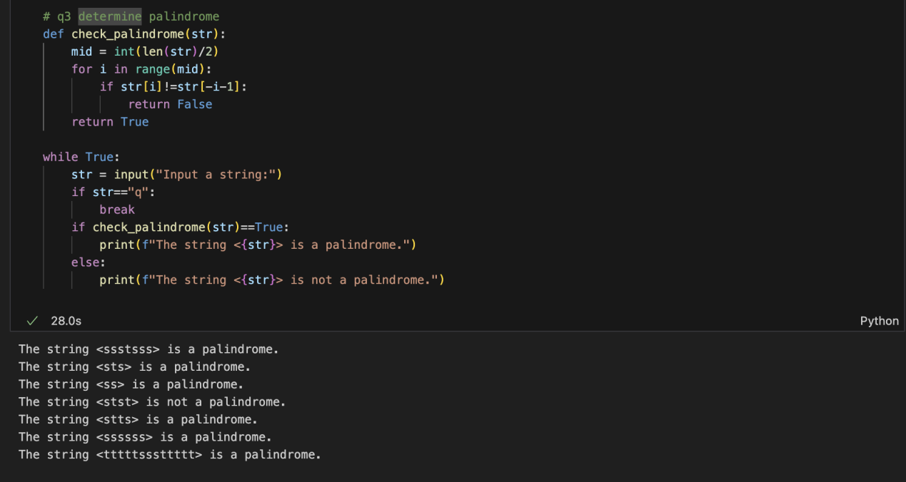

Q4 Write a program that asks the user to input two lists of equal length in the format: [a,b,c], [1,2,3]. The program should test that both lists are of equal length, if not, print out an error message. If they are the same length, combine the two lists by alternaSngly taking elements and output the results. Using the input example above, the output would be: [a,1,b,2,c,3]

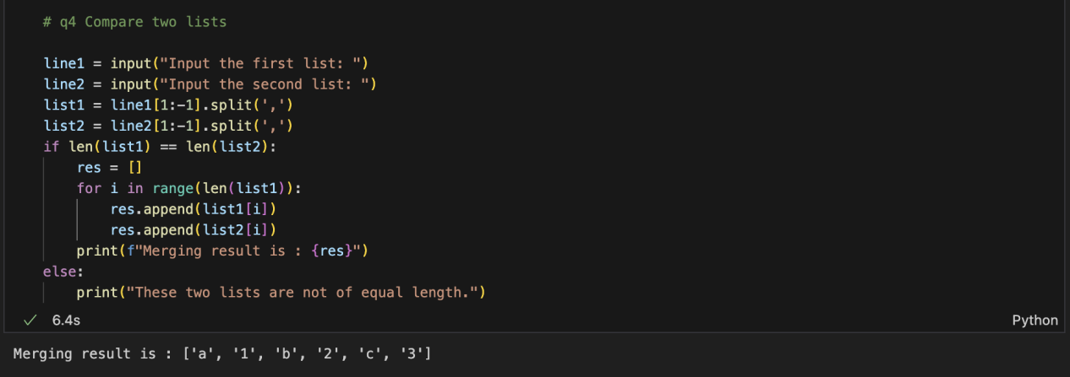

Q5 Write a program that computes the list of the first 100 Fibonacci numbers. The first two Fibonacci numbers are 1 and 1. The n+1 Fibonacci number is computed by adding the n-th and the n-1-th Fibonacci number. The first few are therefore 1, 1, 1+1=2, 1+2=3, 2+3=5, 3+5=8. Print out the results.

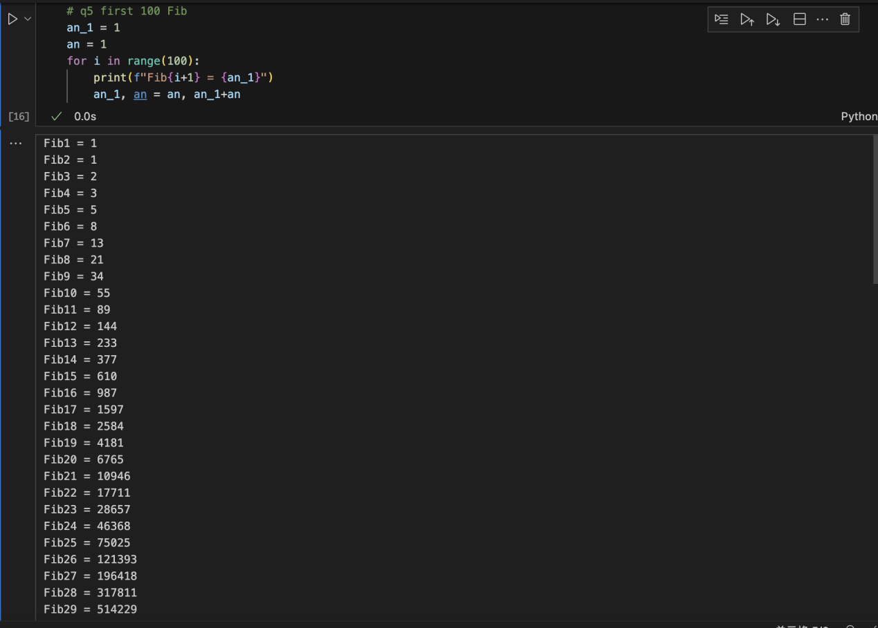

Q6 Write a program that determines if an inpufed year is a leap year

